**The Mountain***Game Design Document*

**Platform**

* PC

**Genre & Theme**

* 3D / First Person Camera
* Dungeon Crawler
* Survival / Roguelike

**Core Inspirations**

* Barony (Art Style / Gameplay / Camera Style)
* Warhammer: Vermintide 2 (Combat Systems)
* Don’t Starve (Survival Design)
* Minecraft (Inventory Systems)
* The Long Dark (Survival Design)

**Gameplay Description**

A 3D Voxel First person styled game based around escaping an underground dungeon while surviving off the resources available to you. Players will have to explore the hand created map to find resources that they can use to venture into the deeper levels of the dungeon and escape. Players will have access to a base containing a giant crystal suspended from the ceiling above a fire pit, this fire pit is linked to all other light sources in the game by sharing the same fire / lighting strength as the campfire. Supply the fire with fuel to heat the crystal or die in the darkness when it extinguishes. Players will have to defend their camp against dungeon monsters how roam the halls of the deep dungeon. The player will slowly rise up the food chain to fight and feed themselves with the apex predators that roam the dungeon.

**Story Description**

The player will awake on the stone-cold floor of the dungeon, with a single flickering light at the end of a tunnel. As the player approaches the light, they are greeted by a warmly lit room containing the bare necessities of survival for a few days. They take a torch from the fire and set about exploring the dungeon.

# **Table of Contents**

Contents

**Overview** 1

**Table of Contents** 2

**Reference Art** 4

**Concept Art** 5

**Concept Art** 6

**Game Goals (Design)** 7

**Basic Mechanics (Design)** 7

**Basic Mechanics - Home Fire (Design)** 8

**Basic Mechanics - Home Fire (Reference Art)** 9

**Basic Mechanics - Home Fire (Engineering)** 9

**Basic Mechanics – Health (Design)** 10

**Basic Mechanics – Health (Reference Art)** 11

**Basic Mechanics – Health (Engineering)** 11

**Basic Mechanics – Hunger (Design)** 12

**Basic Mechanics – Hunger (Reference Art)** 13

**Basic Mechanics – Hunger (Engineering)** 13

**Basic Mechanics – Sanity (Design)** 14

**Basic Mechanics – Sanity (Reference Art)** 15

**Basic Mechanics – Sanity (Engineering)** 15

**World Building – Biomes (Design)** 16

**World Building – Biomes (Design)** 17

**World Building – Biomes (Reference Art)** 18

**World Building – Biomes (Engineering)** 18

**World Building – Home Base (Design)** 19

**World Building – Home Base (Reference Art)** 20

**World Building – Home Base (Engineering)** 20

**Permanent Progression (Design)** 21

**Item Systems (Design)** 22

**Event Log (Design)** 23

**Event Log (Reference Art)** 24

**Event Log (Engineering)** 24

**World Interaction (Design)** 25

**World Interaction (Reference Art)** 26

**World Interaction (Engineering)** 27

**Player Movement & Combat (Design)** 28

**Dungeon Resources (Design)** 29

**Local Coop (Design)** 30

**Save Game State (Design)** 30

**Character Creation (Design)** 30

**Crafting (Design)** 31

**Inventory – Character (Design)** 32

**Inventory – Character (Reference Art)** 33

**Inventory – Character (Engineering)** 33

**Inventory – Chests (Design)** 34

**Inventory – Chests (Reference Art)** 35

**Key Items (Design)** 36

**Control Key Binding (Design)** 36

**Character Leveling (Design)** 37

**Map & Minimap (Design)** 37

**Technical Requirements (Engineering)** 38

**Technical Requirements (Engineering)** 39

**Technical Requirements Listed (Engineering)** 40

**Technical System Flowcharts (Engineering)** 42

# **Reference Art**

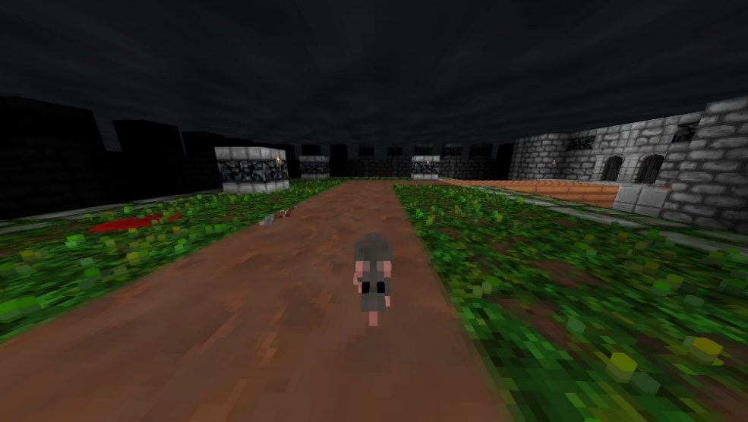

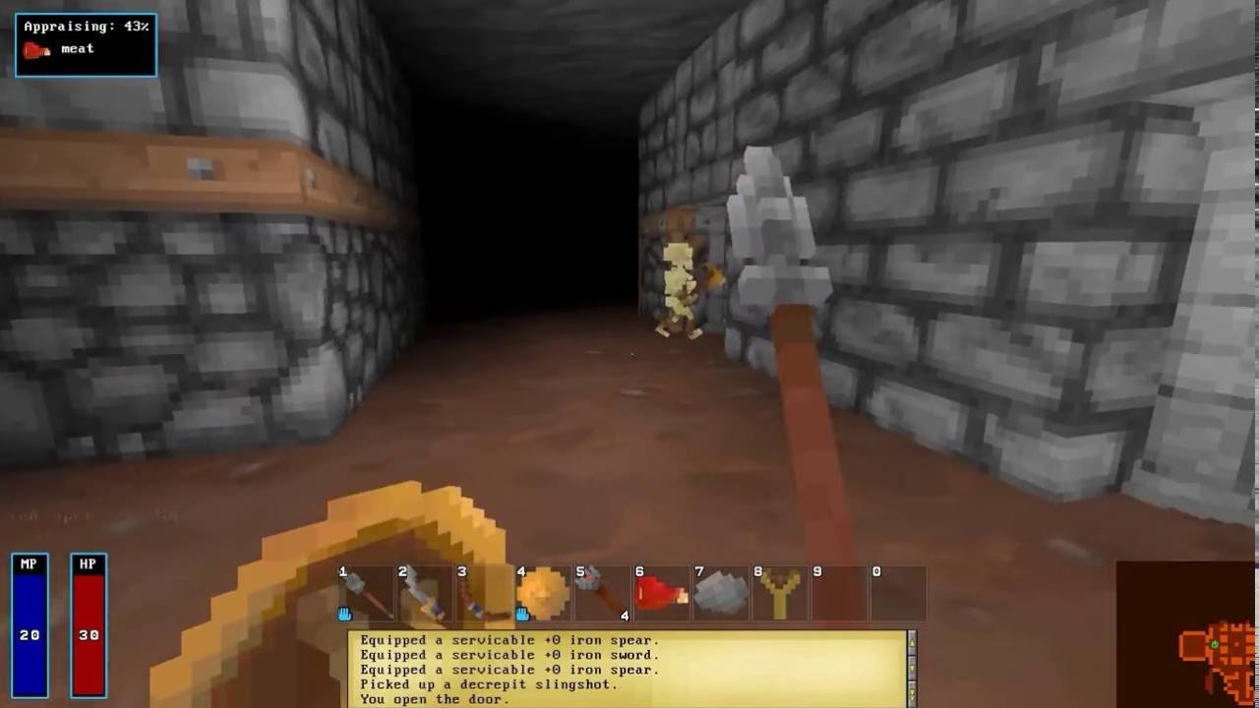

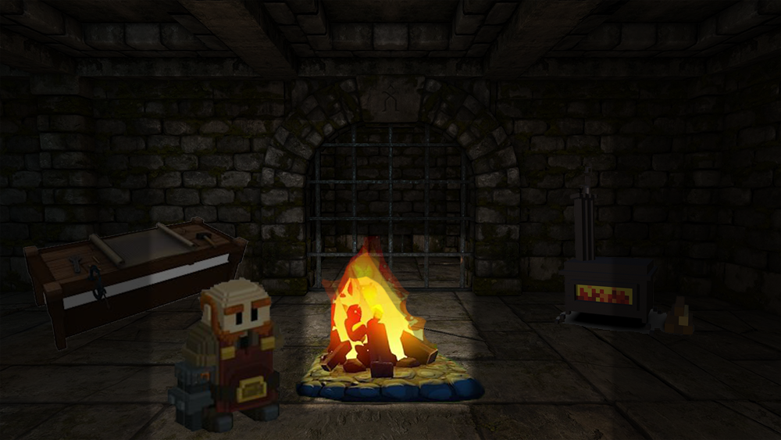

# **Concept Art**

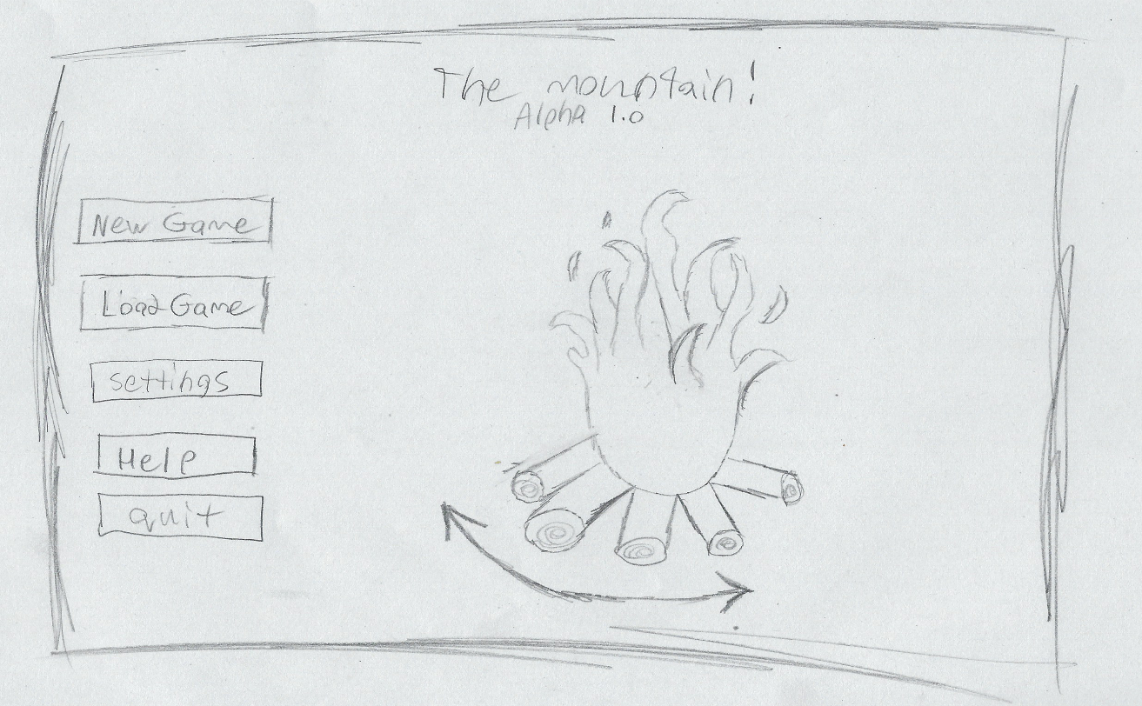

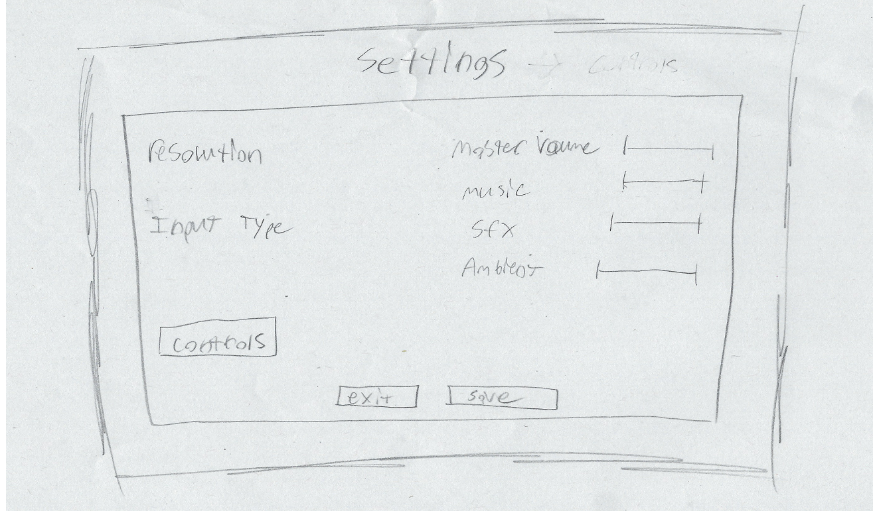

# **Concept Art**

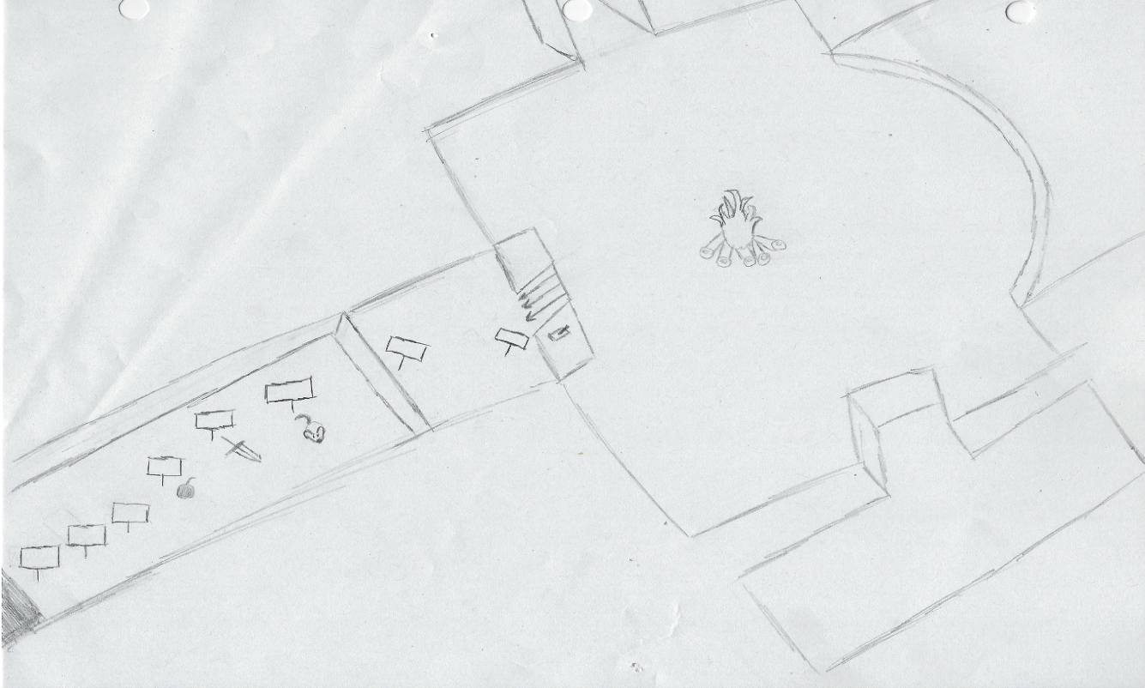

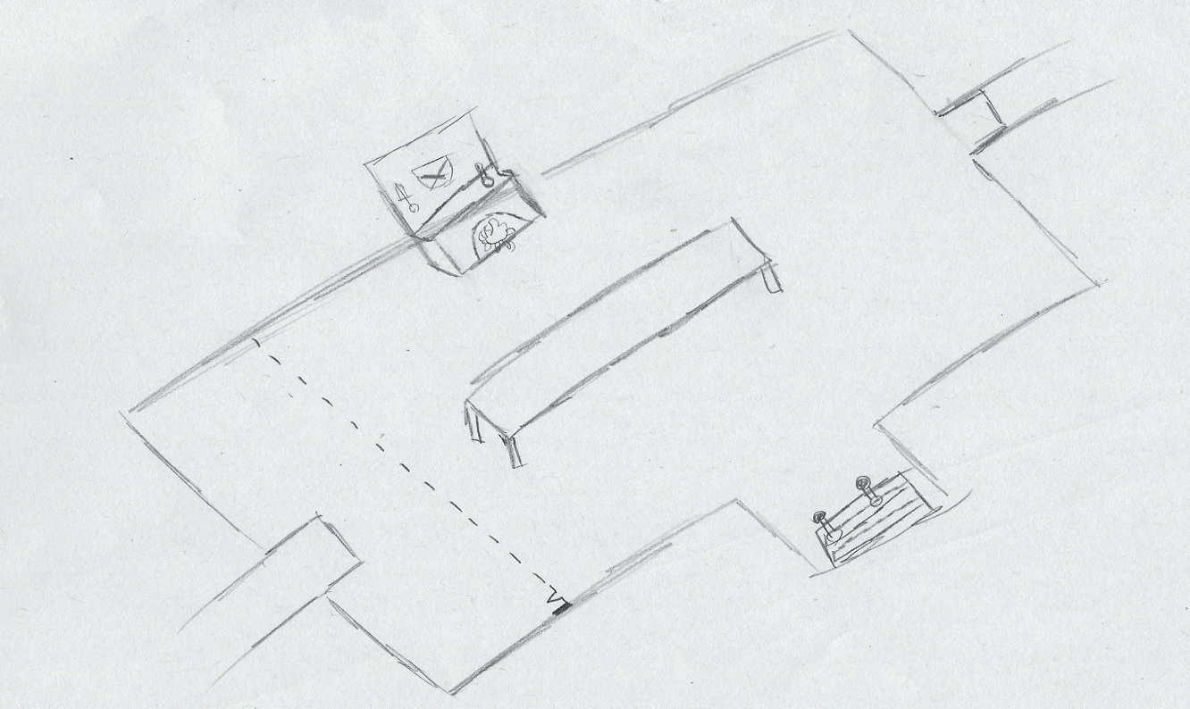

# **Game Goals (Design)**

**Infinite Survival**

Permanently Survive off the land and resources found in the dungeon to reach the best items in the game to make it easier to survive while exploring the dungeon for more loot and resources and fighting harder monsters and bosses.

**Escape the Dungeon**

While exploring the floors of the dungeon players will come across boss rooms some of which are locked by requiring **Key Items** others are accessible from the start of the game. Each boss will be uniquely challenging by engaging on one or more core mechanics. Each boss will drop **Key** **Items** allowing the player to challenging progressively harder bosses. A final boss will drop a **Key** **Item** allowing the player to escape the dungeon. Once the player escapes they game will restart in a new dungeon for new game+, the player will keep their level and equipment but doubling the difficulty of the new dungeon.

# **Basic Mechanics (Design)**

**Lose Conditions**

To survive the harsh environments of **The** **Mountain** players will have to keep up their **Health, Hunger** and **Sanity.** Additionally, the player will also need to keep their **Home Fire** lit by feeding it fuel they can scavenge from the world. The player will directly lose if their **Health** depletes, but the game will be far more challenging to stay alive when their **Hunger** and **Home** **Fire** are depleted as well. If a player dies the world is reset a new following the mechanics of rouge-likes, unless they possess a revival item or structure.

**Game Loop**

The player will fight for survival while also trying to explore deeper into the dungeon to find new materials and equipment. Once the player has explored deep into the dungeon they will come across boss rooms which will leave them **Key** **Items**. These **Key** **Items** will allow them to fight more challenging bosses and unlock new content to make survival easier.

**Win Condition**

Eventually as the player defeats all of the bosses the final **Key** **Item** will let the player escape the dungeon which will unlock **New** **Game+**.

# **Basic Mechanics - Home Fire (Design)**

**Fuelling the Home Fire**

The **Home** **Fire** will constantly require refuelling via the player adding more fuel though UI menus when close. The fire will store 1000/1000 fuel at the start of the game and can be upgraded to hold more fuel so that the player can explore for longer.

**Embers Mode**

If the **Home** **Fire** depletes and runs out of fuel, **Embers** **Mode** will activate. **Embers** **Mode** will make the game much harder by making monsters move faster, hit harder and spawn more often. An added effect to **Embers** **Mode** is that the light level from the linked torch is much smaller than all other stages of the fire level when lit thus making it harder to see around the player. This mode is akin to a panic mode where the player is forced to relight the fire as soon as possible to avoid dying. Visually the fire will have no flame and will pulsate slightly with light same withthe **Heart of the Mountain.**

**Removing Embers Mode**

To remove Embers Mode the player must find a certain room containing a Firestarter and bring it back to the **Home** **Fire** to reignite it. This will become very difficult due to the increase monster difficulty when **Embers** **Mode** is active.

**Linked Torch**

The **Home Fire** acts as the central point of the player’s base but it also acts as a survival and exploration timer to the player as all lights in the dungeon are linked to the **Home Fire**. This means the player can only be away from the base for a small amount of time in early game until they have come back to feed fire again. Once the player progresses, they can choose to spend resources upgrading the **Home Fire** to allow them to travel farther from home. The player will be forced to off-hand a **Linked Torch** at all times which will always indicate the level of the fire back home when exploring by slowly decreasing the light level emitting from the **Linked Torch**.

**Player Base**

The player will start with a bare minimum in their base, just the basic **Home** **Fire**. As the player gathers more resources, they can spend them at the **Home Fire** to unlock / craft more base structures such as a larger **Home Fire** that burns longer, a **Workshop** to craft consumable items, a **Forge** to craft / upgrade weapons, a **Stove** to refine food items.

# **Basic Mechanics - Home Fire (Reference Art)**

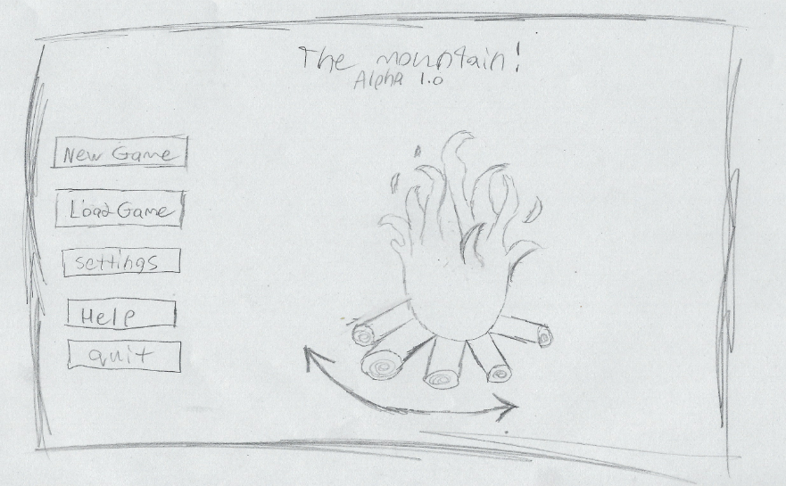

*Home Fire on Title Screen*

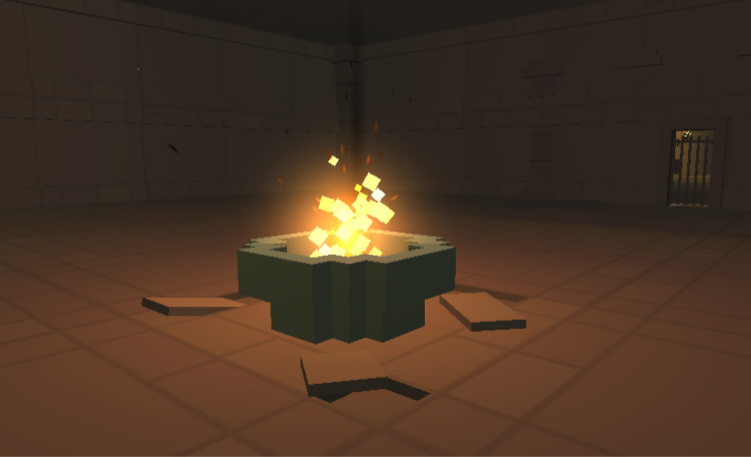

*Home Fire at the Base*

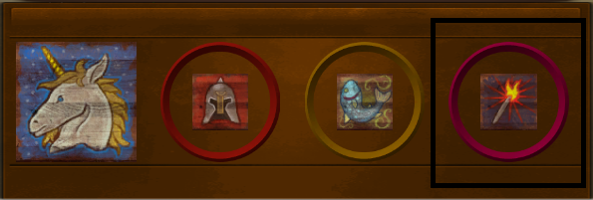

*Fire UI Element*

# **Basic Mechanics - Home Fire (Engineering)**

//////////////////////////////////////////////////////////////////////////////////////////////////////////////

**TM_HomeFireController**

Private void FireLevelDrain_Constant()

Private void FireLevelDrain _Instant()

Private void FireLevelGain_Constant()

Private void FireLevelGain _Instant()

Private void UpdateUI_FireBar()

Private void FireLevel_Below50()

Private void FireLevel_Below20()

Private void Firebar_Empty()

Private void Firebar_Filled()

Private void StartDyingEmbers ()

Private void EndDyingEmbers ()

Private void SetLightLevel()

# **Basic Mechanics – Health (Design)**

**Stats**

The player will start with the maximum Health bar of 100/100. Leveling up will cause the player to gain an extra bit of HP per level.

**Taking Damage**

The player can take damage in several ways, **Monster** **Attacks**, Lack of **Food**, **Dungeon** **Traps, Cold** & **Heat** damage. Armor worn will reduce damage taken.

**Dying**

If the player’s **Health** reaches 0 the player will die and their world will be destroyed, unless they posses a revival item or building.

**Healing**

The player can heal by using items they find in the dungeon or resting at camp. When resting at camp either in a bed or sitting by the fire the player will be charged time sensitive resources such as hunger and fire fuel.

# **Basic Mechanics – Health (Reference Art)**

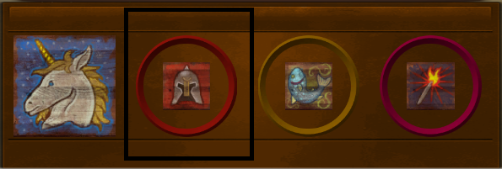

*Health UI*

# **Basic Mechanics – Health (Engineering)**

//////////////////////////////////////////////////////////////////////////////////////////////////////////////

**TM_HealthController**

Private void HealthDrain_Constant()

Private void HealthDrain _Instant()

Private void HealthHealing_Constant()

Private void HealthHealing _Instant()

Private void UpdateUI_HealthBar()

Private void HealthEmpty()

# **Basic Mechanics – Hunger (Design)**

**Stats**

Players will start with the maximum hunger bar of 100/100 and will drain at 10 / per min. Certain upgrades or items may change the hunger cap or drain speed. When hunger reaches 0 the players will drain health slowly at a rate of 50 / per min.

**Finding Food**

Players will be required to find various food sources from the dungeon. The main sources a player will find underground are meat from various monsters, plants and mushrooms growing in certain resources areas as well as processed foods from explored / looted areas.

**Freshness**

All food will start at 100% freshness when picked up by the player then food will start decaying until it becomes rotten mush at 0% freshness. All food types will have a different decay rate and decay only starts when the player has accessed the food item.

# **Basic Mechanics – Hunger (Reference Art)**

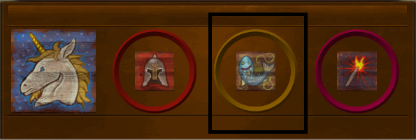

*Hunger UI*

# **Basic Mechanics – Hunger (Engineering)**

//////////////////////////////////////////////////////////////////////////////////////////////////////////////

**TM_HungerController**

Private void HungerDrain_Constant()

Private void HungerDrain_Instant()

Private void HungerFeeding_Constant()

Private void HungerFeeding_Instant()

Private void HungerEmpty()

Private void UpdateUI_HungerBar()

# **Basic Mechanics – Sanity (Design)**

**\*\*\*\*\*\*\*\*\*\*\*\*\*\*\*\*\*\*\*\* REMOVED \*\*\*\*\*\*\*\*\*\*\*\*\*\*\*\*\*\*\*\***

**Stats**

**Sanity** will produce harder / more spawns of monsters attacking the player along with other various visual changes

**Losing Sanity**

When the Home Fire has a light level of less then 50% the player will start to lose

**Recovering Sanity**

When the Home Fire has a light level of less then 50% the player will start to lose

**100% or less**

Monsters will scale their difficulty to match the sanity level, the lower the sanity the harder the monster will spawn.

**50% or Less**

Sanity starts to drain constantly from the player the less sanity you have.

**20% or Less**

Certain doors unlock

The player will start to see monster with slight color palleted changes which cannot be killed but will act like regular monsters and cannot deal damage.

**\*\*\*\*\*\*\*\*\*\*\*\*\*\*\*\*\*\*\*\* REMOVED \*\*\*\*\*\*\*\*\*\*\*\*\*\*\*\*\*\*\*\***

# **World Building – Biomes (Design)**

**Randomization**

Using procedural generation, the world will randomize upon each death. The **Tutorial** **Hall** and the **Home** **Base** will remain as static elements though. The world will use a randomized **Level** **Seed** or allow to input their own at the start of a new game. This seed will be used to spawn **Biomes** and **Rooms** in a random but recreate-able fashion. For each biome in a **Section** each biome will appear at least once allowing for all playthroughs to involve all content but in a different fashion.

**Player’s Base**

Home Base will act as the central point for of the players adventures requiring the player to return here to feed the Home Fire, craft, store loot and upgrade buildings. The players will spawn at the end of a long corridor. On the other end of the corridor the player will find the Home Fire inside a medium sized room, on the left and right will be stone walls that become destructible later into the game. Past the **Home** **Fire** is a large open styled doorway leading to the rest of the world, past here monsters will spawn, and the world will be generally hostile.

**Biome Spawning**

Past the players base each area will always have a biome they will be split into **Biomes** **Pockets** that are interconnecting depending on how far away the spawning room is will determine the pool of biomes to choose from. **Biomes** **Pockets** will have a minimum size of 5 **Rooms** and a max size of 20 **Rooms**. This rule does not apply to **Stone** **Dungeon** Biomes.

**Room Spawning**

Rooms will be linked together with entrance and exit points. Each room will have invisible nodes used as a measurement system for placing objects. Select nodes will be allowed to spawn furniture and interactable elements to further randomly customize the rooms.

# **World Building – Biomes (Design)**

**Player Spawn - (0 - 200 meters from the Home Fire)**

* Stone Dungeon

**Section 1 – (200 – 500 meters from the Home Fire)**

* Stone Dungeon
* Mossy Dungeon
* Mushroom Rooms
* Slime Rooms
* Boss Rooms

**Section 2 – (500 – 800 meters from the home fire)**

* Stone Dungeon
* Slime Rooms
* Frost Rooms
* Heat Rooms
* Boss Rooms

**Section 3 – (800 – 1000 meters from the home fire)**

* Stone Dungeon
* Frost Rooms
* Heat Rooms
* Cave Rooms
* Crystal Cavern Rooms
* Boss Rooms

**Section 4 - (1000+ meters from the home fire)**

* Stone Dungeon
* Stone Hallways
* Final Boss Room

# **World Building – Home Base (Design)**

**Home Fire**

The Home Base will act as the central point for of the players adventures requiring the player to return here to feed the Home Fire, craft, store loot and upgrade buildings. The fire can be upgraded to hold more logs

**Workbench**

One of the first items to be crafted allowing the player to craft more complex structural items at the home fire.

**Furnace**

This station will allow the crafting and upgrading of weapons and armor.

**Kitchen**

The kitchen will allow for the refinement of food items to increase their value to the player or create food out of nonedible items.

**Farm**

This structure will allow the player to grow their own renewable resources while requiring little risk to gather.

**Chests**

Extra inventory space for the player to store items at the base without them despawning. These will each contain 10 items per upgrade but can be upgraded multiple times. They will be combined to a single chest for ease of access.

**Bed**

This will allow the player to rest in bed to recover health rather then sitting around the campfire

**Alchemy Station**

The player can craft potions and utility items here.

**Village**

**Base Defense**

# **World Building – Home Base (Reference Art)**

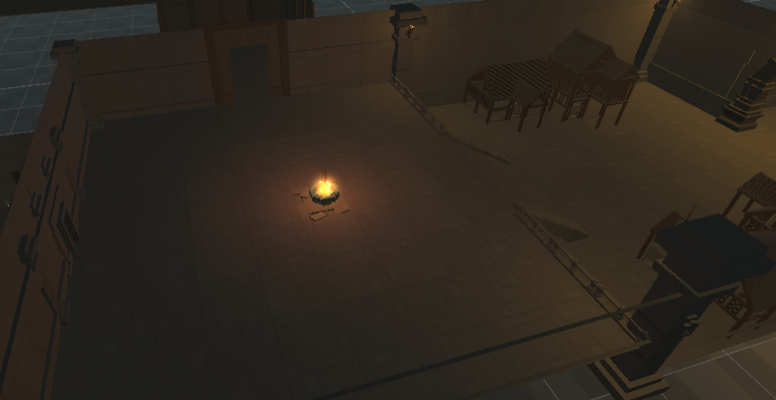

*An Empty Home Base*

# **Permanent Progression (Design)**

Players will gain **EXP** when defeating enemies. EXP earned is not only added to a world’s save file but to the player’s save file a=in the form of **Burnt** **Ember**. **Burnt** **Embers** scores do not reset on the death of a character, rather it is tied to the players account. Players can spend their **Burnt** **Embers** in the in the title screen menu redeeming it for extra content and lore that will appear in the game.

Such items may include lore notes, monster lore pages, character textures or costumes, better loot tables and new monsters. Some of these options may be togglable. Additionally, the player will also gain access to more **NPCs** found in the village around the **Home** **Fire**. Spending **Burnt** **Embers** will make the game slightly easier and add extra content that is not obtainable at the start of the game. This will allow for parallel progression system to work with the characters while keeping progress upon death.

# **Item Systems (Design)**

**Item States**

Each **Item** found in the game will have 3 states, a **UI State** and **a Dropped State** and a **Placed State**. This allows loot found to be either placed on the ground when the world generates (**Placed State)**, found in chests or (**UI State**), or dropped by monsters / the player **(Dropped State).**

**Moving Between States**

Players can drag and drop items out of their inventory to move them from a **UI State** to a **Dropped State** if they do not want the item. **Dropped State** items will be auto picked up by the player when in proximity. Items when dropped will not be picked up by the player for 2 seconds so that they can move away from the item.

# **Item Systems (Reference Art)**

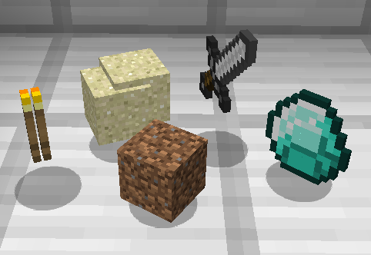

*Minecraft Dropped Items State*

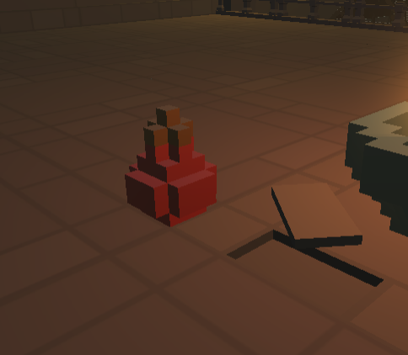

*A Potion in a Placed Item State*

# **Event Log (Design)**

The **Event Log** will be used to specify key actions of events taking place in the game when they occur. The **Event Log** will be attached to many different systems in the game including the **Item System** when Items are picked up for the first time.

The Event Log will output a scrolling text to the player UI screen and text placed in the Event Log will fade out after 5 seconds unless the player hits enter which will toggle on the previous messages until the enter button is hit again.

# **Event Log (Reference Art)**

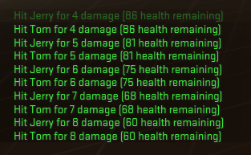  
*An Event Log with damage dealt*

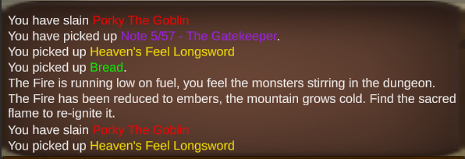

*A colored Event Log prototype*

# **Event Log (Engineering)**

**Adding Text**

Create a Text Mesh Pro scroll item prefab

On new event add text prefab to scroll view at the bottom

Refresh opacity by making text visible on whole visible event log area

Slowly fade out all event log items when new item has not been placed in 5 seconds

Used Text Mesh Pro colors to bold and color text

//////////////////////////////////////////////////////////////////////////////////////////////////////////////

**TM_EventLogController**

Private void SetNewText_Pickup(Item, Color)

Private void TurnOnTextVisablity_Instant()

Private void TurnOffTextVisablity_Slowly()

Private void TurnOffTextVisablity_Instant()

# **World Interaction (Design)**

**Player Interaction Methods**

Players will interact with the world in 4 keyways. **Attacking** objects and creatures, **Tapping** the input button, **Holding** the input button and **Proximity** by being close to an object.

**Attacking**

If a player performs a melee attack and the weapon’s collider enters a collider tagged with the layer “Destructible” then the object will be destroyed and drop its resources onto the ground.

* Defeating Creatures
* Breaking Environmental Structures

**Tap Interaction**

If a player’s collider is inside of the collider of a tap interact object, then a UI text popup under the game cursor will appear. The text will describe the object and action to be preformed in this manner, “Press E to interact”.

* Looting Items in a **Placed** **State**
* Interactions with the Home Base Structures

**Hold Interaction**

If a player’s collider is inside of the collider of a hold interact object, then a UI text popup under the game cursor will appear as well as an empty circle icon around the cursor. The text will describe the object and action to be preformed in this manner, “Press E to interact”. While the hold button is being held an empty circular icon will fill up clockwise until it is full, in which case the action Is “completed”. If the button is let go at any point the action will not be completed and returned to a zero value.

* Opening Dungeon Chests
* Levers
* Disabling traps

**Proximity Interaction**

Items on the ground in a **Dropped State** will be auto picked up by the player when in the players collider hits the item’s collider.

* Picking up items in a **Dropped** **State**.

# **World Interaction (Reference Art)**

*****Hold Interaction*

**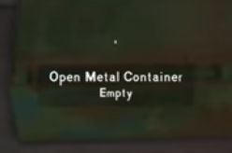***Tap Interaction*

# **World Interaction (Engineering)**

//////////////////////////////////////////////////////////////////////////////////////////////////////////////

**TM_Weapon**

Private void OnCollider()

Private void DealDamage()

**TM_IntractableObjectTap**

Private void OnCollider()

Private void OpenUI_Tap()

Private void TapUI()

Private void FinishTapUI()

**TM_IntractableObjectHold**

Private void OnCollider()

Private void OpenUI_Hold()

Private void HoldingUI()

Private void FinishHoldingUI()

**TM_IntractableObjectProximity**

Private void OnCollider()

Private void CheckForSpaceInInventory()

Private void PickupItem()

# **Player Movement & Combat (Design)**

**Player Movement**

Players can move in first-person with the **WASD** keys. The movement system will be using a lag-less or no delay input system meaning the animations will looks less lifelike at the expense of the responsiveness.

**Player Extra Movement**

Players can use the **SHIFT** key to sprit at the cost of stamina while outside of combat, when a player is in combat ranged the **SHIFT** key will preform a dodge / leap action in the direction the player is moving or default to a backwards leap if no other input is detected. Players can use the **SPACE** key to jump at no stamina cost.

**Combat Actions**

**Melee** weapons will use a stamina bar which recharges when not attacking, sprinting or dodging. They will be swung with **LMB**. **Magic** or **Utilities** items will cost mana which recharges when not casting a spell. They will be used with **RMB**.

**Combat Stats**

Attacks will have a **Range**, **Damage**, **Cooldowns**, **Knockback** and **Stamina** / **Magic** cost when used. This system will lead the combat to be a more reaction / skill-based combat system focusing on damage output.

**Combat Skills**

Each of the unique classes with be given 3 basic active skills unique to their class which will change the dynamics of what weapons they are good at and their playstyle.

**Combat Input**

Tap Left Mouse - **Swing**

Hold Left Mouse - **Power** **Swing**

Block + Tap Left Mouse - **Parry** **Stun**

Forward Movement + Space - **Jump**

Side / Back Movement + Space - **Dodge**

# **Dungeon Resources (Design)**

**Food**

Food found in The Mountain will be displayed visually showing Health, Sanity and Food levels that will be obtained by eating this item, some values can be negative when eaten. Food will also contain a freshness value which when expired the food will turn to mush. Placed resources do not start their freshness timer until the item is picked up.   
Example: **Raw Meat**.

**Crafting Materials**

The player will com across many items in the game, some may require extra crafting steps to become useful.   
Example: **Wood**.

**Key Items**

Key items will be found from fighting bosses and can be used to unlock the next set of boss fight rooms.  
Example: **Key of Light**.

**Mobs Spawn Points**

Mobs will spawn initially in most rooms, but other rooms will also contain mob spawners so that mobs are constantly generated even when the room is cleared. These spawners will include passible mobs as well as aggressive ones. This will allow for mob resources farming from these rooms.   
Example: **Rat Spawner.**

**Resource Nodes**

Some resources will be infinitely spawn-able from resources nodes, these like mob spawn points will be found in rooms and can be harvested for renewable materials. These resources nodes will have limited resources but will replenish on a timer once taken.   
Example: **Mining** **Iron** **Node**.

# **Local Coop (Design)**

The game will be built around supporting a basic local coop option allowing for 2 players to play simultaneously with each other. Controller support will use 2 Xbox one controllers. This will be the version to demo when presenting the project. They will share a Home Fire level but will have individual health, hunger and sanity levels. When one player is killed the world will not reset, but instead the player will get a chance to reset their character. Both players will lose however if the **Home Fire** is extinguished.

# **Save Game State (Design)**

The player will be allowed to only save at the Home Fire for simplicity. All inventories will be saved along with the world spawn, but all current world creature spawns will be reset. Players will get the option to load their save from a save slot but the save slot will only retain one save per playthrough. For example, a player may have many playthrough each with their own save state accessible in the main menu. But never more then one saves state of single playthrough to avoid save-scumming.

# **Character Creation (Design)**

At the start of the game the player will have the option to choose between 3 premade dwarven characters each based around one combat stat. The stats are **Strength**, **Speed** and **Magic**. Choosing your class will section off certain combat options making them less effective due to class differences or restrictions. For example, magic cannot be used by every class at the start of the game.

Character will start with a bare minimum of equipment to prepare themselves for the dungeon’s early levels.

# **Crafting (Design)**

Items can be crafted for added value, recipes will unlock as the player acquires new items. Certain materials and crafting items may be biome or distance restricted requiring the player to venture deeper in **The Mountain** to find them.

Various **Resources** can be found in **The Mountain** to help the player survive or craft such as scrap **Wood**, **Metal**, **Weapon** **Parts**, **Armor** **Parts**, **Leather** and **Rope**. Each of these resources can be used in the **Crafting** system to improve the player or the player’s base.

# **Inventory – Character (Design)**

**Backpack**

The player will have an inventory system using both a backpack and a hot bar for quick item usage. The players backpack will be 10 items per row and 3 backpack rows with 1 hot bar row. The backpack rows will start locked and can be upgraded from the workbench to unlock the rest of the backpack.

**Moving Items Around**

Items can be moved be selecting them to bind them to the cursor and selecting a new spot to place the item. If the position is already filled then it swaps the items. If the inventory is closed when while and item is bound to the cursor then it will drop the item on the floor. If and area outside of the backpack is selected with and item bound it will be dropped from the player as well. Shift clicking on an item will auto move the item to the other area the item is not currently in. This includes backpack, chests and the hot bar areas.

# **Inventory – Character (Reference Art)**

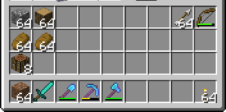

*Minecraft Styled Inventory UI*

# **Inventory – Character (Engineering)**

**Adding an Item**

**Dropping an Item**

//////////////////////////////////////////////////////////////////////////////////////////////////////////////

**TM_PlayerInventoryController**

Private void AddNewItem (Item, Color)

Private void SelectItem()

Private void AttachItemToCursor()

Private void PlaceItemInSlot ()

Private void SwitchItemInSlot()

Private void DropItem()

Private void UseItem()

# **Inventory – Chests (Design)**

**Loot chests**

Chests found around the dungeon will contain loot for the player to find and obtain. They will be a smaller 2 by 5 area though not all places must be full when spawning loot.

**Player Owned Chests**

Chests crafted by the player in the workbench will be automatically placed in the storage room by the home fire. Players can craft up to 10 of these chests to store their items at home.

# **Inventory – Chests (Reference Art)**

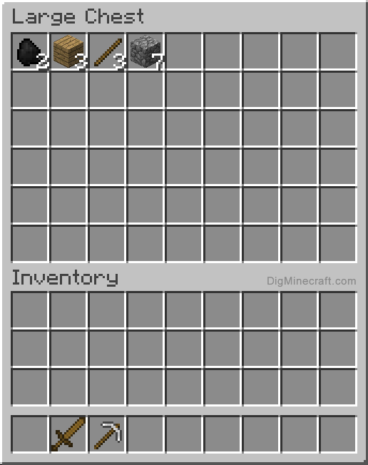

*Minecraft Styled Inventory UI*

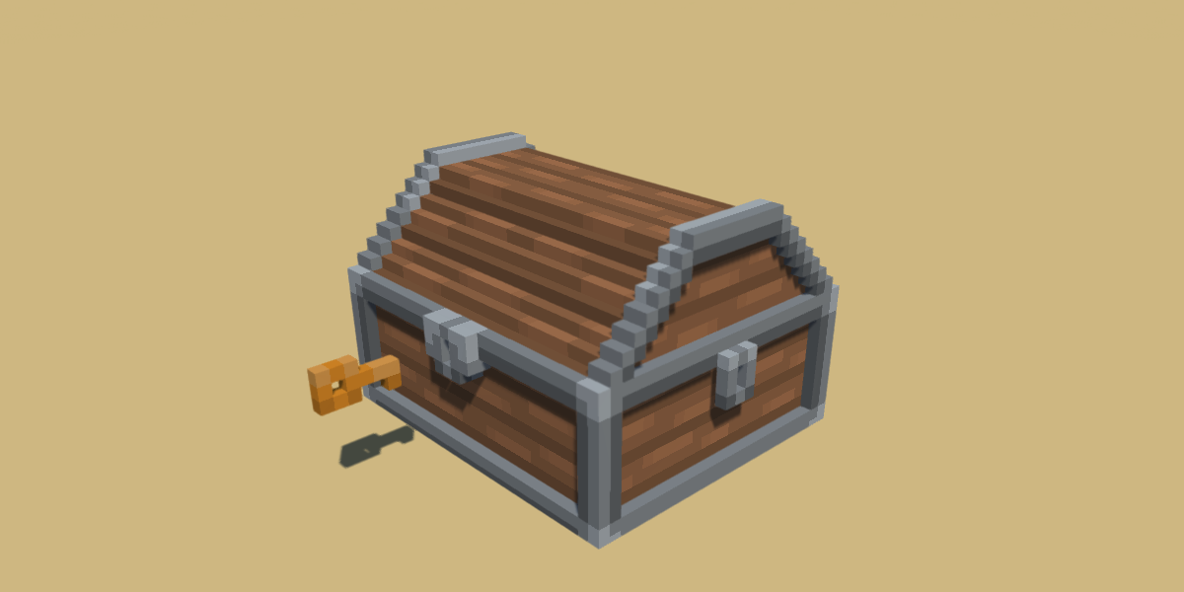

*Voxel Styled Chest*

# **Key Items (Design)**

Certain **Key** **Items** can be found by defeating boss monsters in their respective rooms. These **Key** **Items** will allow you to interact and unlock certain door leading to more bosses. The final boss will drop a **Key** **Item** allowing you to escape **The** **Mountain**.

# **Control Key Binding (Design)**

**Key binding Design**

The game will feature a customizable key binding system allowing the input from the player translated to the game to change.

**Default Actions & Bindings**

|  |  |
| --- | --- |
| **MOVEMENT** |  |
| Move Forward | W |
| Move Backwards | S |
| Move Left | A |
| Move Right | D |
| Sprint | Left Shift |
| Dodge | Space |
| Jump | Space |
| Crouch | Left Cntrl |
|  |  |
| **INTERACTION** |  |
| Interact | F |
| Open Inventory | E |
| Use Offhand Item | Mouse 3 |
|  |  |
| **COMBAT** |  |
| Melee Attack | Mouse 1 |
| Magic | Mouse 2 |
| Skill 1 | 1 |
| Skill 2 | 2 |
| Skill 3 | 3 |
| Skill 4 | 4 |

# **Character Leveling (Design)**

**Leveling Up**

Characters can level up by defeating monsters how will have a set amount of **EXP** to give to the player when slain. Players will start at level 1 and can reach level 30 as a max, level 20 will be the highest expected level to be reached though as levels 20 through 30 required very high amounts of **EXP** to obtain. Every level up a player will be granted 5 stat boosters they can use on which ever stats they want, these will allow the player to build their own character to the environment and play style they wish.

**Stats**

When a player is granted stats, they will be allowed to spend them at any point to increase the power of the player.

**Monster Level Scaling**

Monsters in the game will scale with the players level depending on which biome the player is currently

# **Map & Minimap (Design)**

A map will be given to the player to help them oriented themselves Inside the dungeon and explore. It will be generated as a 2D version of the tops of the rooms and foreach room discovered it will be unveiled in the map.

# **Technical Requirements (Engineering)**

**Core –** Required to have a functional prototype at the end of the semester

**Additional –** Extra mechanics that should be in the game to make it enjoyable

**Bonus –** Cool features that would be nice to have but might require more work then they are worth

**Systems Required**

* Title Screen
  + Buttons
  + Settings
  + Credits Screen
  + Custom Key Binding
* Basic World Building
  + Handmade Rooms
  + Dungeon Procedural Generation
* Character Movement Input
  + Walking
  + Jumping
  + Running
  + Dodging
* Character Status Systems
  + Health
  + Hunger
  + Sanity
* Character Melee Combat System
  + Attacking Colliders
  + Dealing Damage
  + Receiving Damage
* Monsters
  + Attacking Colliders
  + Pathfinding
* World Interaction
  + Attacking
  + Tap
  + Hold
  + Proximity
* Final Room

# **Technical Requirements (Engineering)**

* Character Inventory
  + Disable character Input
  + Drag and Drop
  + Shift Click
  + Sort
* Loot System
* Pause System
* Crafting Systems
* Save Game State
* Basic Animations / Lighting
* Boss Fights
* Music
* Sound Effects
* Utility Items
* Doors
* Local Coop / Controller Support
* Magic Combat
* Character Customization
* Map
* Minimap

# **Technical Requirements Listed (Engineering)**

**Route 1**

1. World Generation
2. Biome Generation
3. Room Designs
4. Resource Nodes
5. Loot Nodes
6. Save State

**Route 2**

1. Player Movement
2. Player Jumping
3. Player Dodging
4. Player Melee Attacking
5. Player Taking Damage
6. Player Dying
7. Game Over Reset
8. Player Item Pickup
9. Player World Interactions
10. Player Using Items
11. Player Ranged Attacking
12. Final Goal Interaction

**Route 3**

1. Player Hunger UI
2. Player Health UI
3. Player Fire UI
4. Home Fire
5. Player Hunger System

**Route 4**

1. Database Design
2. Event Log Menu
3. Debug Spawning

**Route 5**

1. Monster Spawning
2. Monster Pathing
3. Monster Taking Damage
4. Monster Dying
5. Monster Loot / EXP
6. Monster Attacking
7. Bosses

**Route 6**

1. Model Integrations
2. Title Screen
3. Pause Screen
4. Player Inventory
5. UI Art Integrations
6. Sound Integrations
7. Player Settings
8. Player Equipment
9. Player Skill levelling

**Route 7**

1. Crafting
2. Character Creation
3. SFX Manager
4. Music Manager
5. Credit Screen
6. Key Items
7. Player Leveling
8. Key Binding
9. Controller Support
10. Permanent Progression
11. Doors

# **Technical System Flowcharts (Engineering)**

